- Create an S3 bucket and upload some objects to S3.

• Login to AWS Console
• Search S3
• Open Amazon S3
• Click Create bucket
Create Bucket

Upload Objects
- Open your bucket
- Click Upload
- Click Add files
- Upload some files, for example:
  - index.html
  - error.html

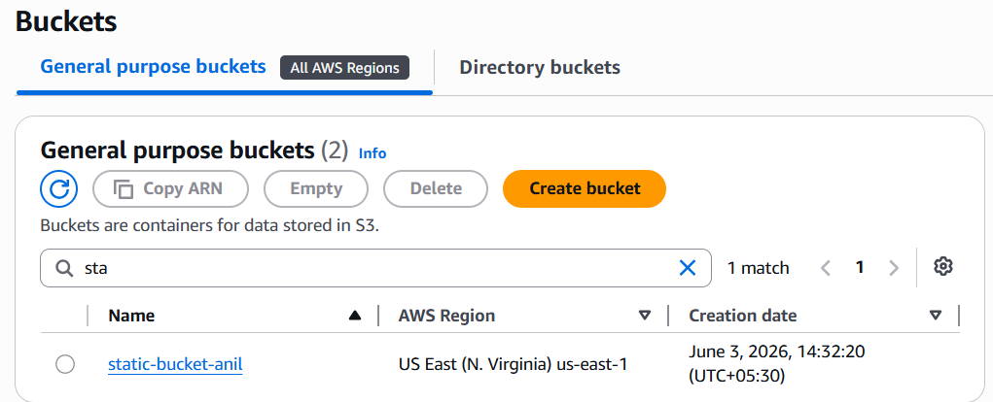
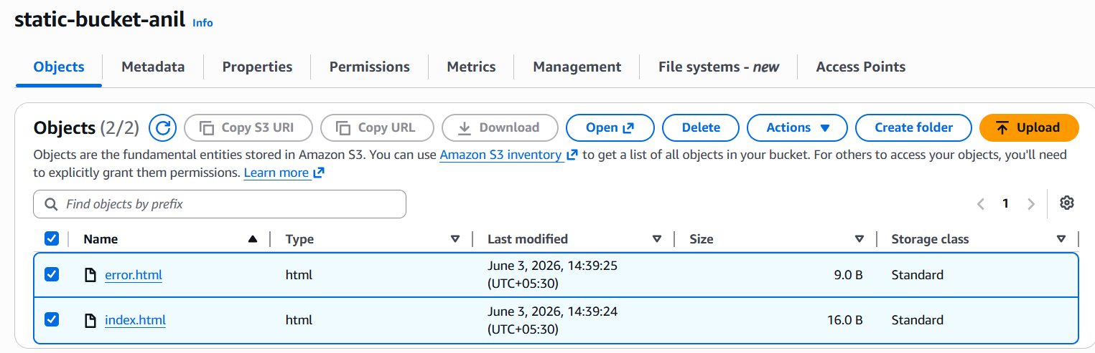

- Deploy a static website in the S3 bucket.

Step 1: Create Website Files
On your laptop, create a file named index.html
Create another file named error.html
Upload both files into your S3 bucket.

Step 2: Enable Static Website Hosting
- Open your S3 bucket
- Go to Properties
- Scroll down to Static website hosting
- Click Edit
- Select Enable
- Hosting type: Host a static website
- Index document: index.html
- Error document: error.html
- Click Save changes
The index document is the default page S3 returns when someone opens the website root URL.

Step 3: Disable Block Public Access
Because this is a public static website, users need read access.
- Open your bucket
- Go to Permissions
- Click Block public access
- Click Edit
- Uncheck Block all public access
- Confirm by typing confirm
- Save changes
AWS says that to make the website publicly readable, you must disable Block Public Access and add a bucket policy granting public read access.

Step 4: Add Bucket Policy
Go to:
Bucket → Permissions → Bucket policy → Edit
Paste this policy:
{
"Version": "2012-10-17",
"Statement": [
{
"Sid": "PublicReadGetObject",
"Effect": "Allow",
"Principal": "*",
"Action": "s3:GetObject",
"Resource": "arn:aws:s3:::bucketname-demo/*"
}
]
}

Step 5: Test Website
- Go to Properties
- Scroll to Static website hosting
- Copy the Bucket website endpoint
- Open it in a browser
It will look something like:
http://bucketname.s3-website-us-east-1.amazonaws.com

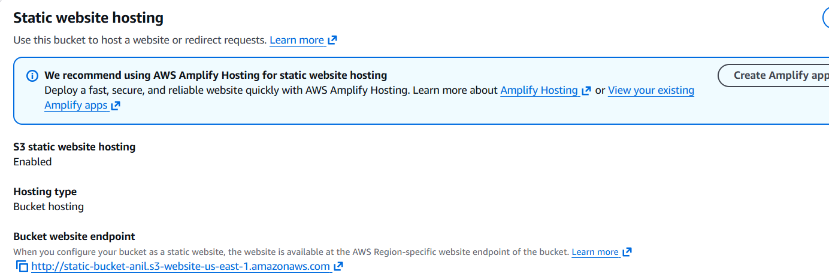
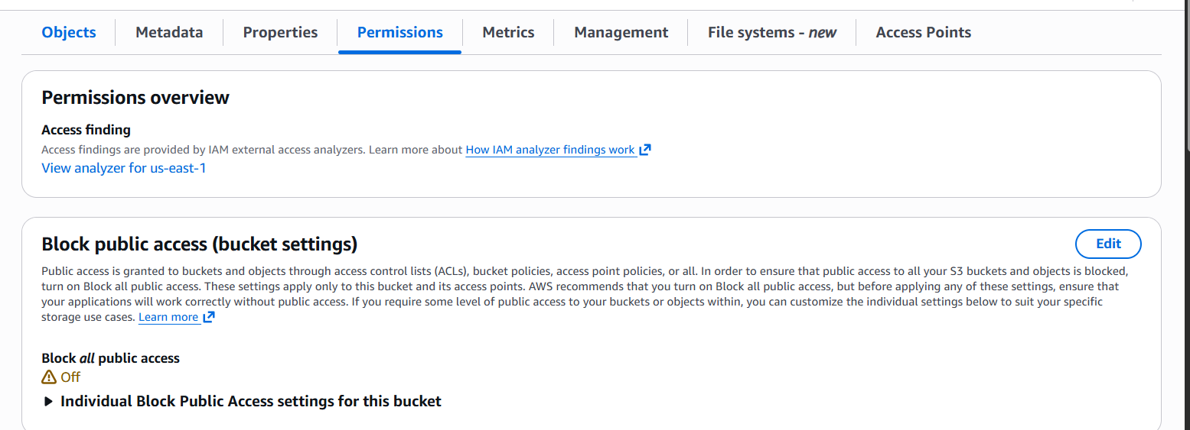

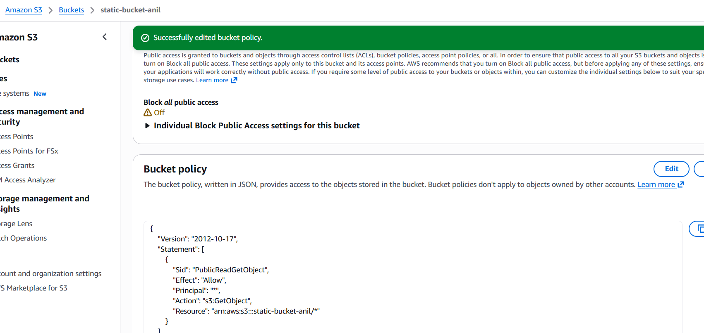
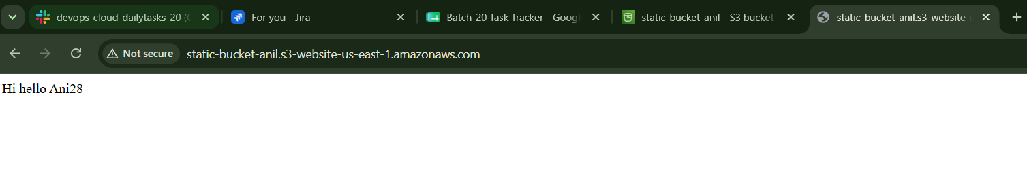
3.Enable cross-region replication on S3 buckets

S3 Cross-Region Replication, or CRR, automatically and asynchronously copies new objects from one S3 bucket in one AWS Region to another S3 bucket in a different AWS Region. AWS says replication can be used across different Regions, same Region, same account, or different accounts

Step 1: Create Destination Bucket
Go to S3 → Create bucket.
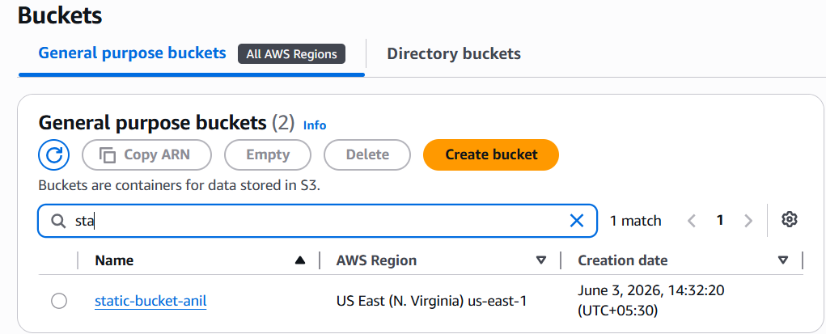
Step 2: Enable Versioning on Source Bucket
- Go to Properties
- Scroll to Bucket Versioning
- Click Edit
- Select Enable
- Click Save changes
This is mandatory for replication.
Step 3: Enable Versioning on Destination Bucket

Step 4: Create Replication Rule on Source Bucket
Now go back to your source bucket:
static-bucket-anil
Then:
- Open Management tab
- Scroll to Replication rules
- Click Create replication rule
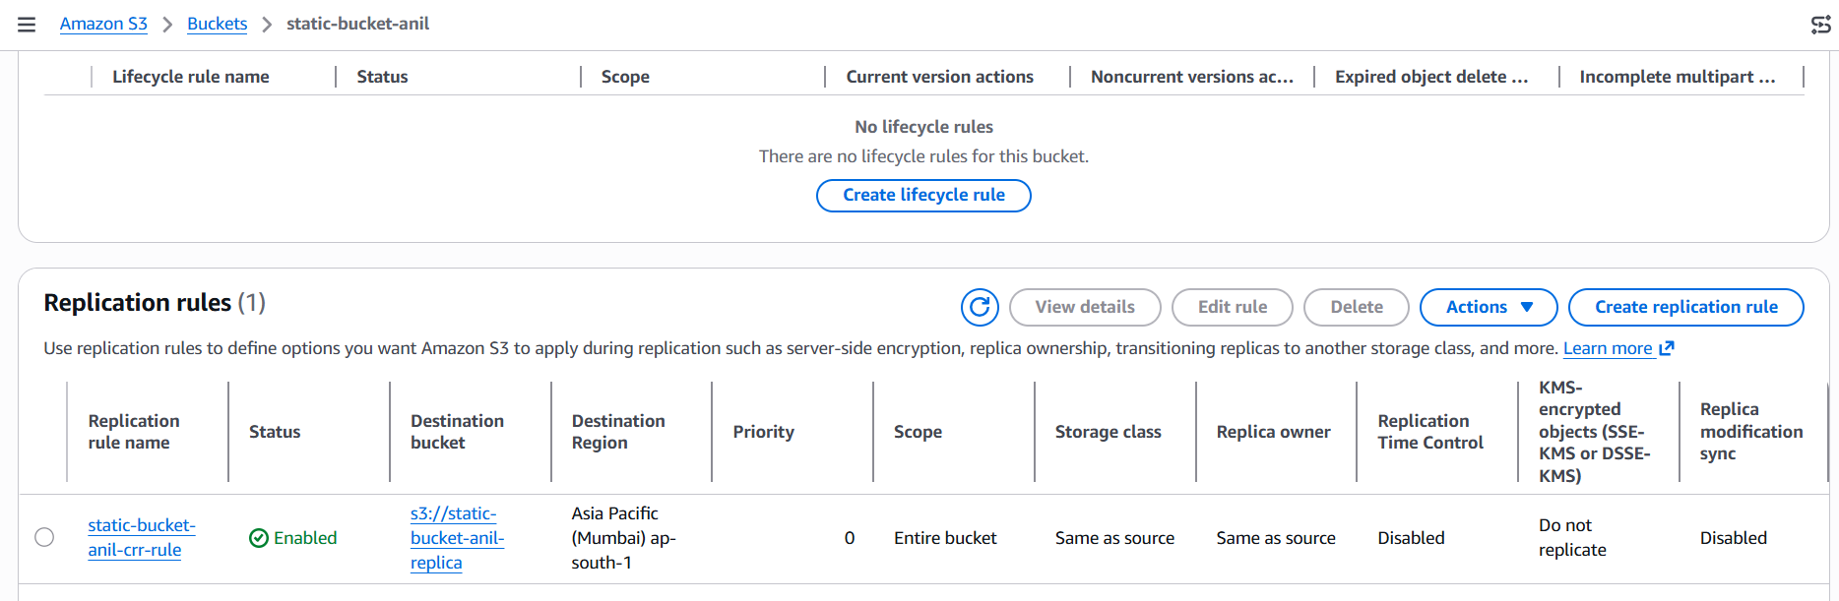

Step 5: Upload a New File to Source Bucket
Open:
static-bucket-anil
Go to Objects → Upload → Add files.
Upload a new file, for example:
replication-test.txt

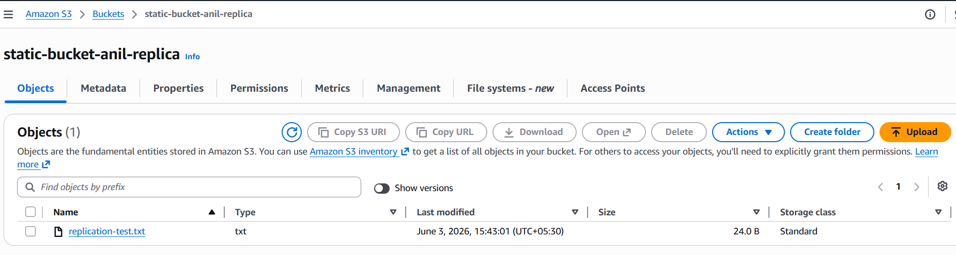

Step 6: Check Destination Bucket
Open:
static-bucket-anil-replica
Wait 1–5 minutes and refresh.
You should see:
replication-test.txt
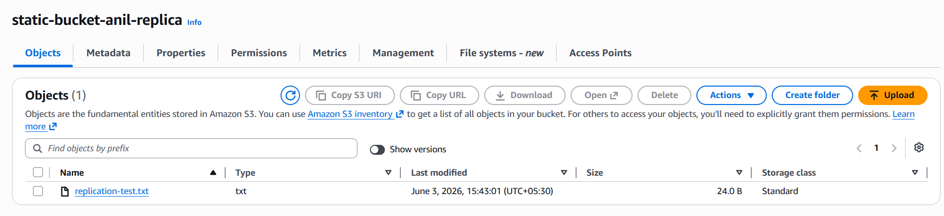

- Configure a bucket policy so only the Admin user can see the objects of the S3 bucket

Step 1: Get Admin User ARN
First, find the exact ARN of your Admin IAM user.
- Go to AWS Console
- Search IAM
- Click Users
- Open your Admin user
- Copy the ARN
It will look like this:
arn:aws:iam::123456789012:user/Admin
Keep this ARN ready.
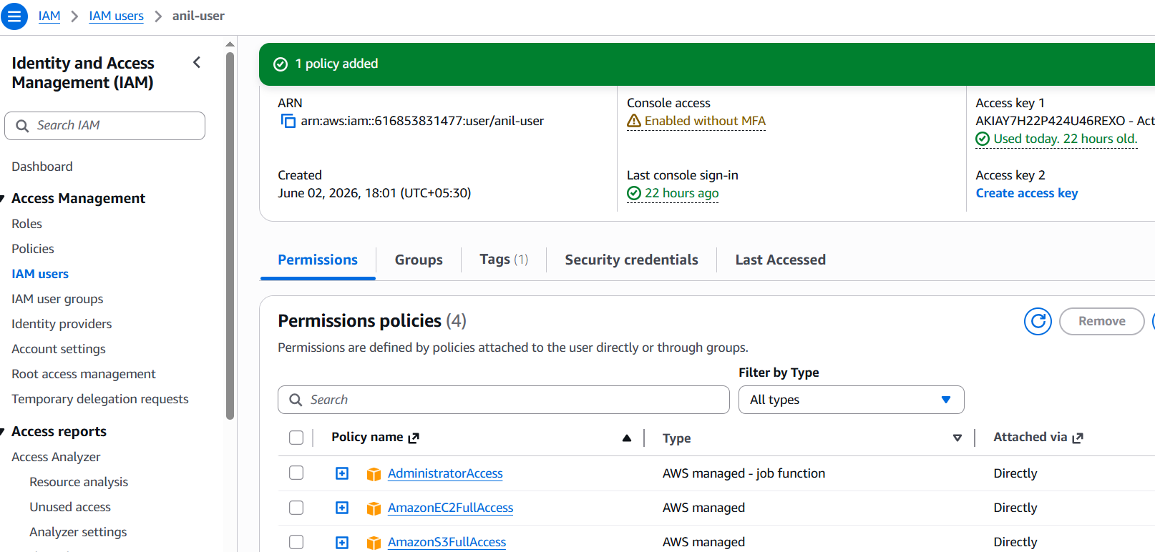

Step 2: Go to Bucket Policy
Now go to:
S3 → static-bucket-anil → Permissions → Bucket policy → Edit
Before adding this policy, remove the old public website policy if you added one earlier.
Your old public policy probably looked like this:
"Principal": "*",
"Action": "s3:GetObject"
Remove that because it allows public access.
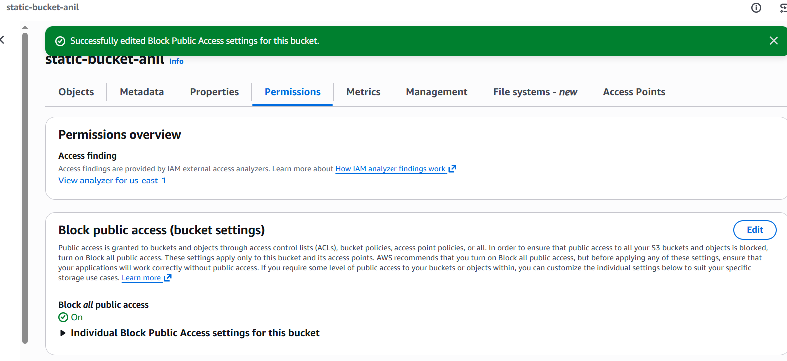

Step 5: Test
Login as the Admin IAM user and open the bucket.
Admin should be able to:
Open bucket
See object list
Open/download objects
Any other IAM user should get:
Access Denied
when trying to list or view objects.

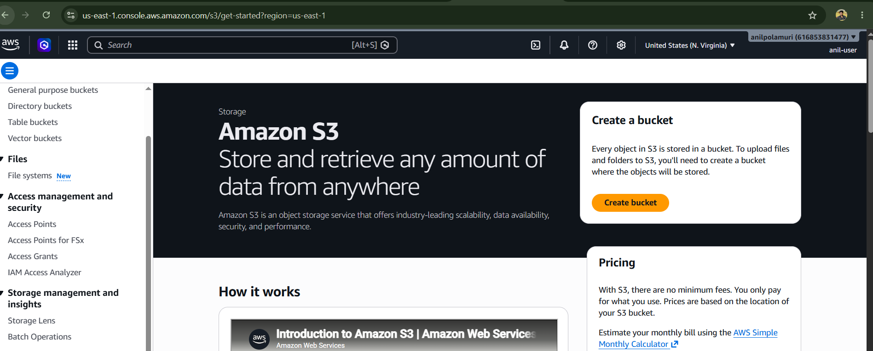
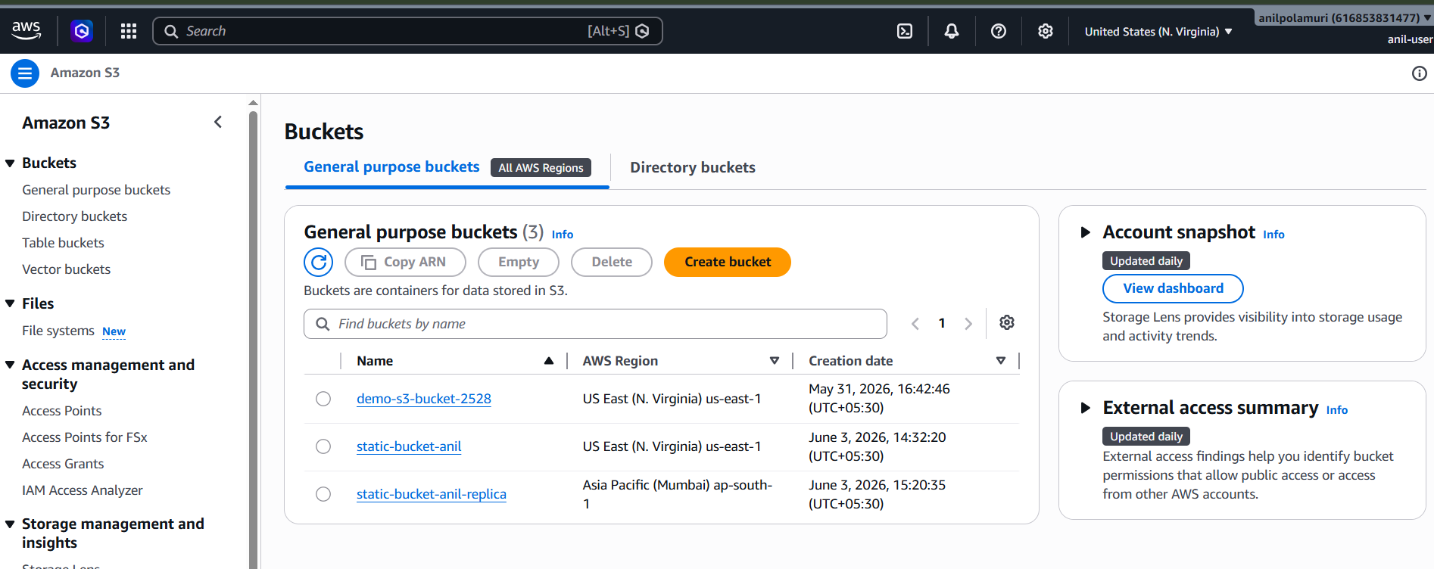
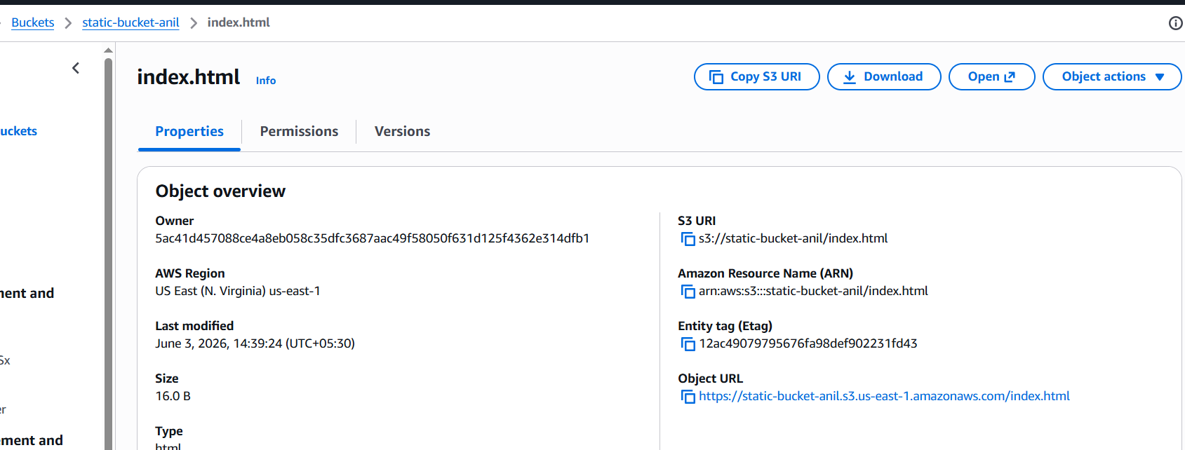
Any other IAM user should get:
Access Denied
when trying to list or view objects.
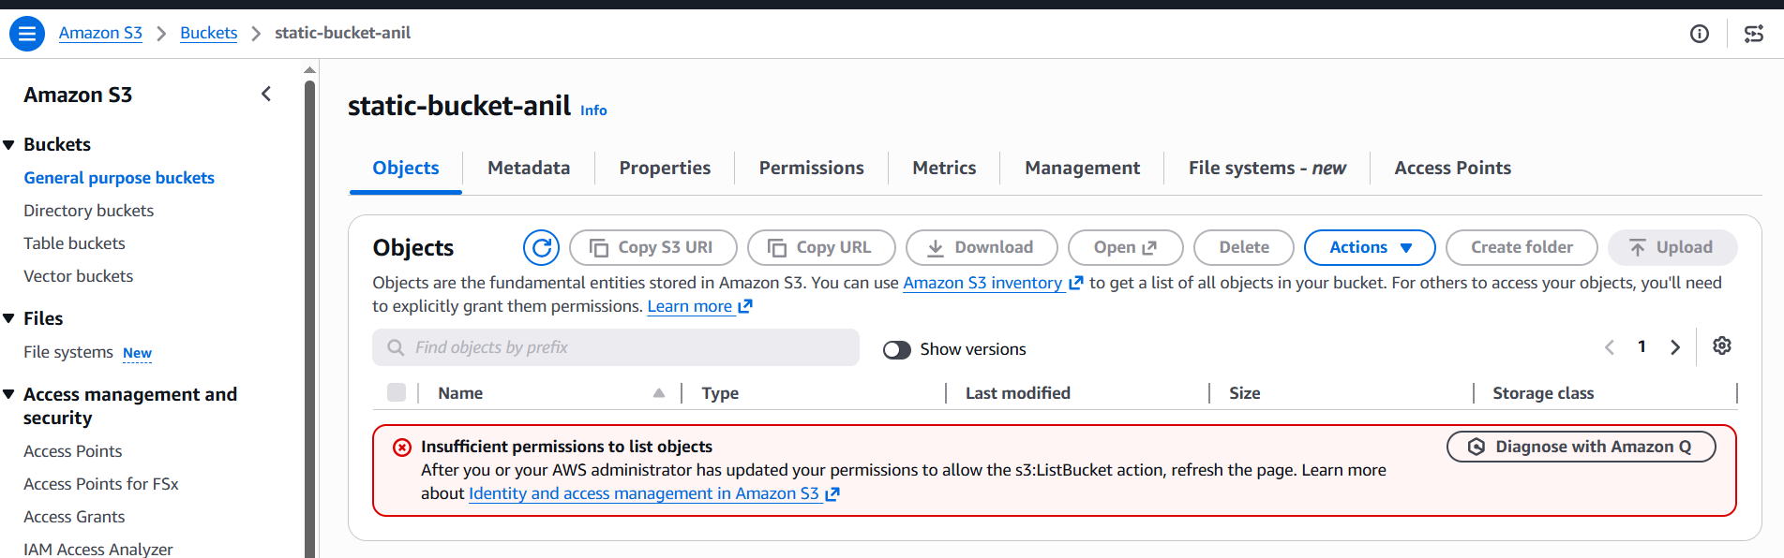

5.Set up lifecycle policies to automatically transition or delete objects based on specific criteria
Purpose: A lifecycle policy automatically moves objects to cheaper storage classes or deletes them after a certain number of days. AWS says S3 Lifecycle rules can transition objects to less-expensive storage classes, archive them, or delete them

Step 4: Choose Rule Scope
For basic task, select:
Apply to all objects in the bucket
AWS may show a checkbox like:
I acknowledge that this rule will apply to all objects in the bucket
Select that checkbox.
This means every object inside static-bucket-anil will follow this lifecycle rule.
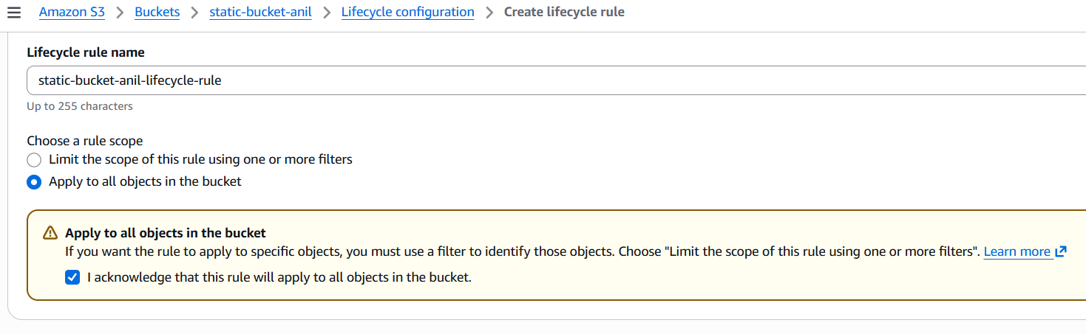

Step 5: Choose Lifecycle Rule Actions
Select these options:
Move current versions of objects between storage classes
Expire current versions of objects
Delete expired object delete markers or incomplete multipart uploads
If your bucket has versioning enabled, you may also see options for noncurrent versions. For your basic task, focus on current versions.
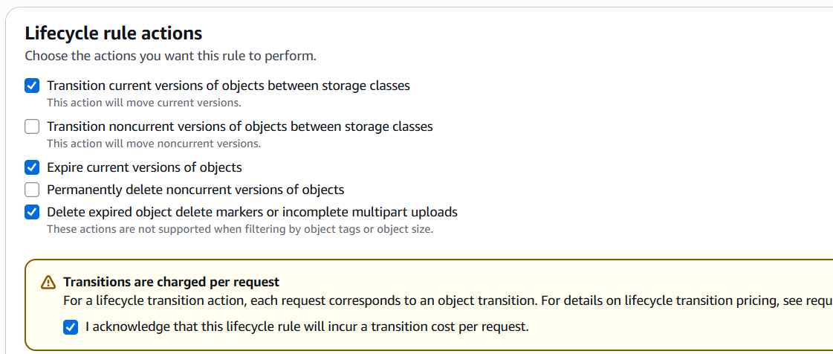

Step 6: Add Transition to Standard-IA
In Transition current versions of objects between storage classes:
Choose:
Standard-IA
Days after object creation:
30
Meaning:
After 30 days, objects move from Standard storage to Standard-IA.
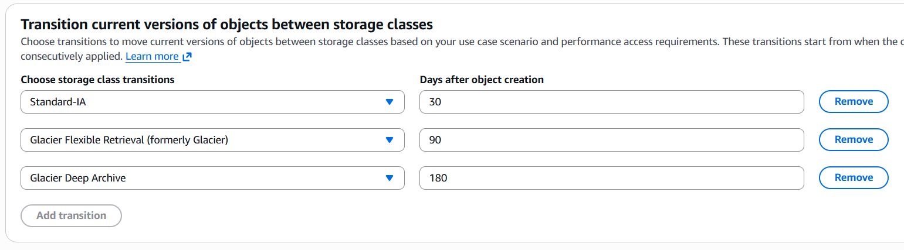

Step 7: Add Expiration
In Expire current versions of objects, enter:
365
Meaning:
After 365 days, S3 deletes the objects.
AWS calls this an expiration action, where S3 deletes objects at the end of their configured lifetime.
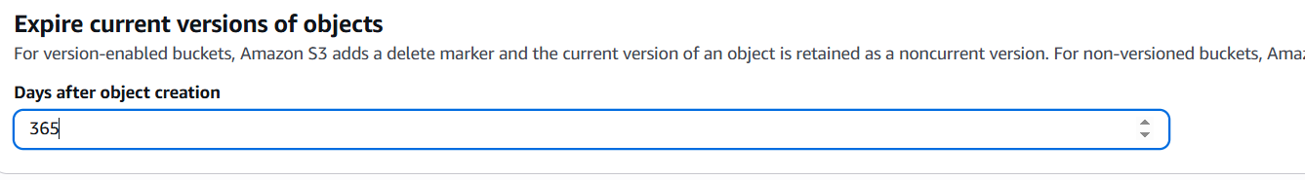

Step 8: Incomplete Multipart Upload Cleanup
If you see this option:
Delete incomplete multipart uploads
Enter:
7
Meaning:
If a multipart upload is started but not completed, S3 deletes the incomplete parts after 7 days.
This saves storage cost.
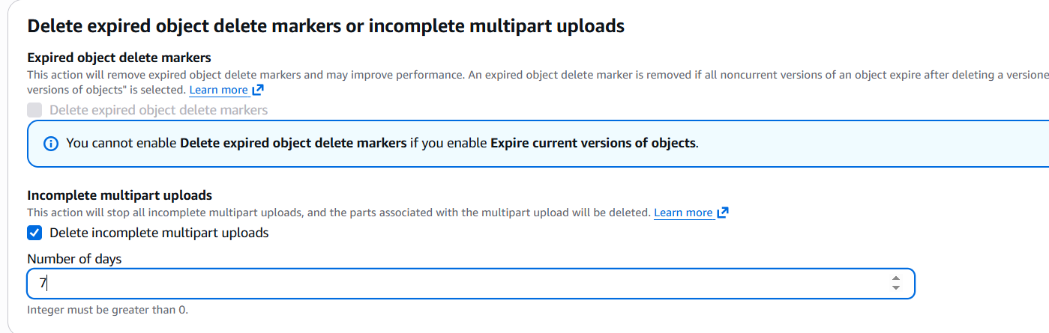
Step 9: Review and Create Rule
Amazon S3 lifecycle actions are asynchronous and there can be delay. AWS notes that lifecycle transition or expiration dates are rounded to midnight UTC the next day, and actions may not happen immediately.
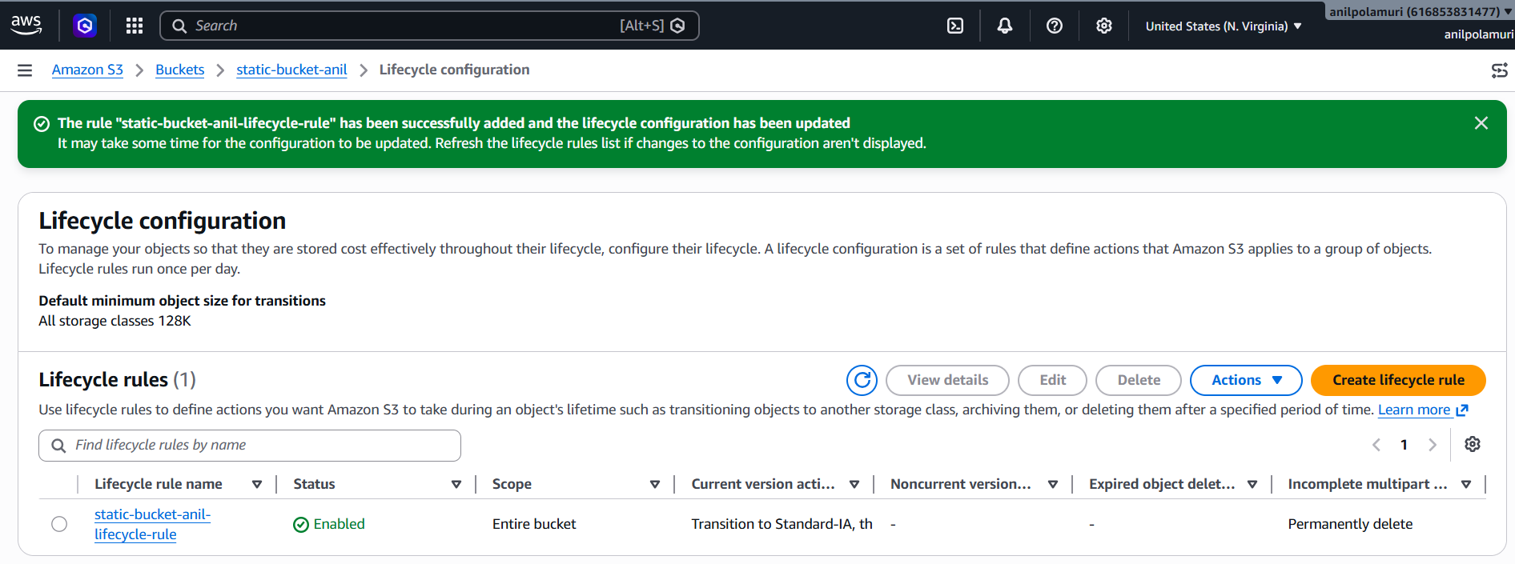

7.Push some objects to S3 using the AWS CLI.

Step 1: Open Git Bash / Command Prompt
Open:
Git Bash

Step 2: Check AWS CLI Installed
Run:
aws --version

Step 3: Configure AWS CLI
Run:
aws configure

Step 4: Check If You Can Access S3
Run:
aws s3 ls
You should see your buckets.
To check your specific bucket:
aws s3 ls s3://static-bucket-anil

Step 5: Create Some Sample Files Locally
Go to Desktop:
cd Desktop
Create a folder:
mkdir s3-upload-test
cd s3-upload-test
Create sample files:
echo "This is file one uploaded using AWS CLI" > file1.txt
echo "This is file two uploaded using AWS CLI" > file2.txt
echo "This is file three uploaded using AWS CLI" > file3.txt
Check files:
ls
You should see:
file1.txt
file2.txt
file3.txt

Step 6: Upload One Object to S3
Upload one file:
aws s3 cp file1.txt s3://static-bucket-anil/
This uploads file1.txt directly into the bucket.

Step 7: Upload Multiple Objects / Folder to S3
Upload the full folder content:
aws s3 cp . s3://static-bucket-anil/ --recursive
or use sync:
aws s3 sync . s3://static-bucket-anil/
Difference:
aws s3 cp --recursive = copies all files
aws s3 sync = copies only new/changed files
For real-time DevOps work, sync is commonly used.

Step 8: Upload to a Folder Inside S3
If you want to upload into a folder called cli-uploads/, run:
aws s3 cp . s3://static-bucket-anil/cli-uploads/ --recursive
Now your files will appear like:
cli-uploads/file1.txt
cli-uploads/file2.txt
cli-uploads/file3.txt
This is best for your task because your lifecycle rule may use prefix like:
logs/
or
cli-uploads/

Step 9: Verify Uploaded Objects
Run:
aws s3 ls s3://static-bucket-anil/
To check inside folder:
aws s3 ls s3://static-bucket-anil/cli-uploads/
To check recursively:
aws s3 ls s3://static-bucket-anil/ --recursive

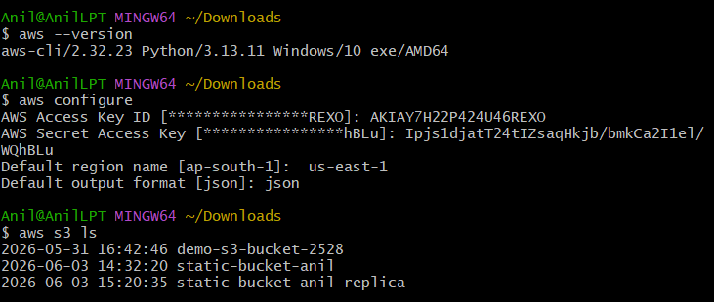
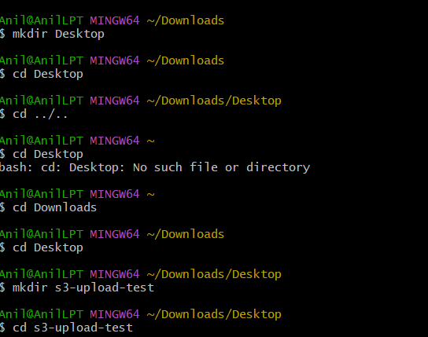
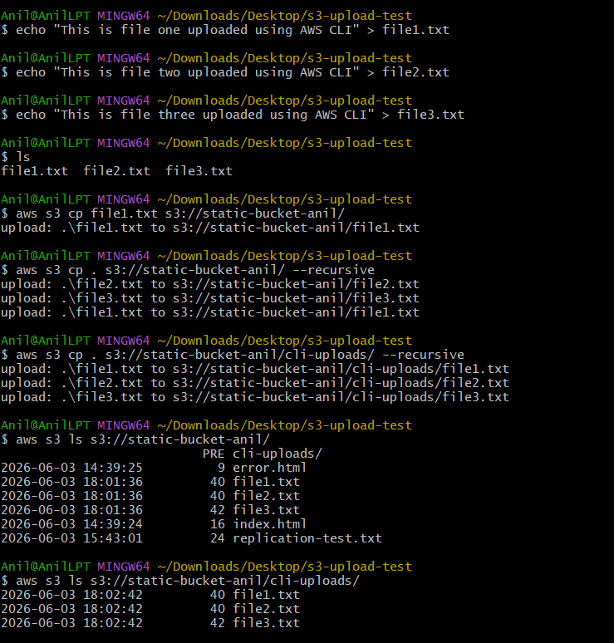

Step 10: Verify in AWS Console
Go to:
S3 → static-bucket-anil → Objects
Click refresh.
You should see the uploaded files.
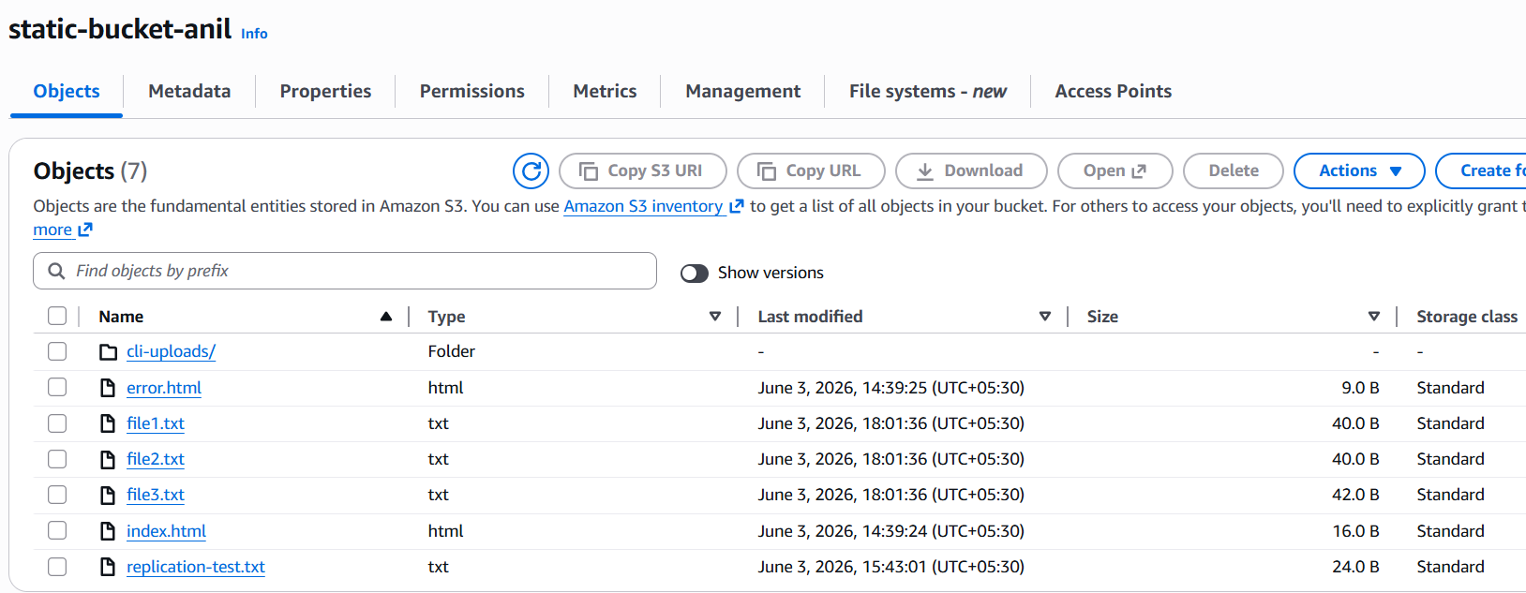

8.Write a Bash script to create an S3 bucket

Step 1: Open Git Bash
Open Git Bash on your laptop.
Check AWS CLI:
aws --version
Check which AWS user is configured:
aws sts get-caller-identity
You should see your account/user details.

Step 2: Create Bash Script File
Run:
nano create_s3_bucket.sh
Paste this script:
#!/bin/bash

# Bash script to create an S3 bucket using AWS CLI

BUCKET_NAME="static-bucket-anil-script-demo"
REGION="us-east-1"

echo "Creating S3 bucket: $BUCKET_NAME"
echo "Region: $REGION"

# Check if AWS CLI is installed
if ! command -v aws &> /dev/null
then
echo "AWS CLI is not installed. Please install AWS CLI first."
exit 1
fi

# Check if bucket already exists
if aws s3api head-bucket --bucket "$BUCKET_NAME" 2>/dev/null
then
echo "Bucket already exists: $BUCKET_NAME"
exit 0
fi

# Create S3 bucket
if [ "$REGION" = "us-east-1" ]; then
aws s3api create-bucket \
--bucket "$BUCKET_NAME" \
--region "$REGION"
else
aws s3api create-bucket \
--bucket "$BUCKET_NAME" \
--region "$REGION" \
--create-bucket-configuration LocationConstraint="$REGION"
fi

# Check if bucket creation was successful
if [ $? -eq 0 ]; then
echo "S3 bucket created successfully: $BUCKET_NAME"
else
echo "Failed to create S3 bucket."
exit 1
fi

# Enable versioning
aws s3api put-bucket-versioning \
--bucket "$BUCKET_NAME" \
--versioning-configuration Status=Enabled

echo "Versioning enabled for bucket: $BUCKET_NAME"

# Show bucket list
echo "Current S3 buckets:"
aws s3 ls

Step 3: Give Execute Permission
Run:
chmod +x create_s3_bucket.sh

Step 4: Run the Script
Run:
./create_s3_bucket.sh

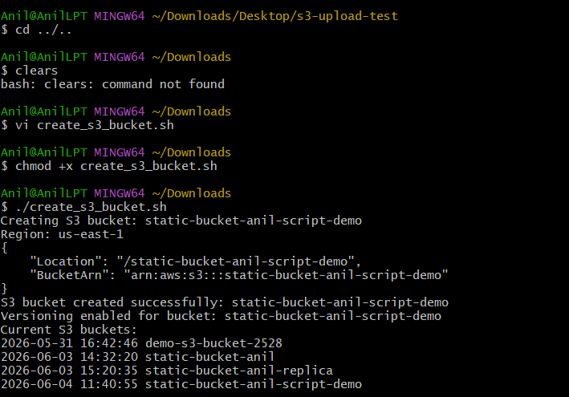

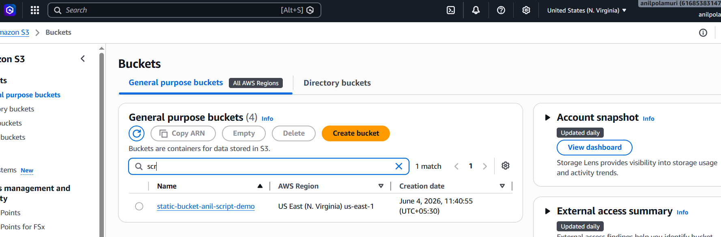

9.Upload a 1 GB file to S3 using the CLI.

1. First check AWS CLI is installed
Open Git Bash / Terminal / CMD and run:
aws --version
Expected output looks like:
aws-cli/2.x.x

2. Configure AWS CLI
aws configure
Enter:
AWS Access Key ID: your-access-key
AWS Secret Access Key: your-secret-key
Default region name: us-east-1
Default output format: json
Use the region where your S3 bucket exists.

3. Create a 1 GB test file

If you are using Git Bash
dd if=/dev/zero of=1gb-test-file.bin bs=1M count=1024

4. Check file size

Git Bash / Linux / Mac:
ls -lh 1gb-test-file.bin

5. Upload the 1 GB file to S3
Use this command:
aws s3 cp 1gb-test-file.bin s3://your-bucket-name

6. Upload to a folder inside S3 bucket
If you want to upload inside a folder:
aws s3 cp 1gb-test-file.bin s3://your-bucket-name/uploads

7. Verify the file uploaded
aws s3 ls s3://your-bucket-name/

